

**2011**

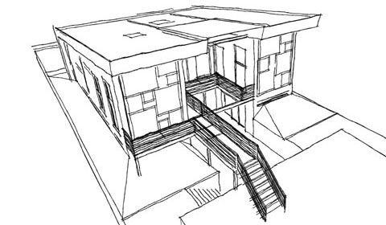

Project Proposal Document

Sponsor: Res Communis

Advisor: Dr. Douglas V. Hall

Students:

Hai Nguyen

Hieu Nguyen

Nam Nguyen

Michael Stoltz

Michael White

Date: Feb – 28 – 2011

Open Source Home Energy Reduction System (OSHERS)

Rev 4

**Executive summary**

The Commons is designed to be a fully functional, resource independent dwelling that incorporates many energy saving designs and has a secondary benefit of reducing the impact on the environment. To further aid in the energy savings, further enhancements to the Commons is required.

Automation and monitoring of key systems such as water consumption, power usage, and lighting are but a few solutions; the owner can benefit from the following:

* The creation of a sensor network that is linked to a central server
* Motion Sensors to monitor motion within a given space or room
* The ability to analyze power usage by capturing real-time power data
* Real-time monitoring of water level and water flow via sensors to accurately track water usage in the dwelling and if needed, modify water usage habits
* Provide the means to control outputs via server, such as the closing of blinds to reduce heat and automation of home composting toilet
* Meet the sponsor’s goal of a low cost solution

**Introduction**

The sensor nodes provide a real-time acquisition of data on key metrics and then wirelessly transmits that data via the JeeLabs JeeNode platform. The JeeNode platform meets our goal of interfacing with four (4) sensors (ambient light, temperature, humidity, and motion sensing) as well as providing the wireless communication platform necessary to transmit data to a central server.

The JeeNode platform provides the project with flexibility and expansion opportunities to not only meet the current project site needs, but as an open-source solution to a myriad of other home deployments. The added benefits of the JeeNode platform are low component cost, for both sensors and JeeNode wireless board, requires only a modicum of programming knowledge and has a low energy requirement for operation.

**Scope**

As automation and sensor technology grows, an increase in home deployment will also continue to grow. In this proposal, we will describe the features of our solution and how it will meet the needs of the Res Communis project. We will then outline some risks and dependencies and how we will address those risks. Finally, we will outline the per room cost and overall project cost.

**Proposal format**

For ease of reference, we have divided the remainder of this proposal into the following sections:

* System Overview
* Overview of the JeeLabs JeeNode & Sensors
* Overview of the Outputs
* Communication Protocol
* Documentation
* Risks and Dependencies
* Predictable Cost – provides cost information

**System Overview**

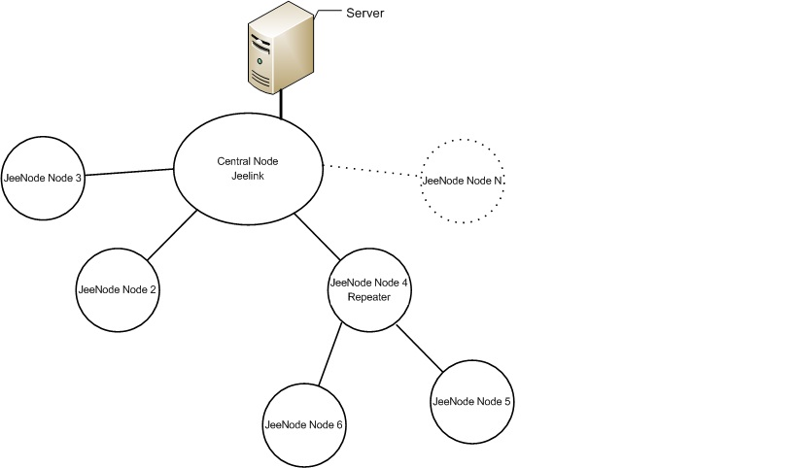This section provides an overview of the proposed system. Figure 1 is a node diagram of a wireless sensor network.

**Figure 1: Node diagram of a wireless sensor network**

In Figure 1, the server can send commands to the central node (JeeLink) to ask the system to perform a specific task such as getting the temperature, the light level, the humidity, sensing motion, controlling various motor outputs, dimming the lights, etc. The central node (JeeLink) will send the appropriate request to a specific JeeNode node to perform the task.

With its sensor and radio communications capability, a JeeNode is capable of sensing its environment for temperature, light level, humidity, etc.; transmitting or receiving this data to or from other nodes. However, when a JeeNode is out of range from the central node (JeeLink, node 6 and node 5 in Figure 1), the data cannot be transmitted between these two nodes. Thus, we need an “intermediate” node to act as a repeater, forwarding this data.

In addition to sensing the environment, transmitting and receiving data, some JeeNodes are also responsible for controlling outputs such as motors, dimming of lights and outlets. Also, because the JeeNode platform is a low-power platform, JeeNode nodes consume little power when they are in the running mode. Therefore, we can achieve one of our objectives, which is power-saving.

**Overview of the JeeNode – based platform and sensors**

**JeeNode**

The consensus has been that the JeeNode meets every requirement for our project at the minimum price. The JeeNode comes unassembled and is simple to build with modest soldering skills. It has an Atmel ATMega328p micro-controller on board, coupled with an RF module for radio communication. This combination enables both digital and analog multiple sensor acquisition and data to be relayed to a participating remote device.

The JeeNode is compatible and programmable with the extremely popular Arduino IDE and libraries, making it flexible and well supported. The JeeNode will be at the heart of this system as a sensor node, an interface and as an output controlling device.

Downloadable software for the JeeNode and its four basic sensors will be loosely based on the rooms.pde source code available from JeeLabs.net.

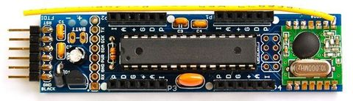

**Figure 2: picture of JeeNode assembled**

**JeeLink**

The JeeLink is essentially a pre-assembled JeeNode with additional onboard memory and a USB port. It will be used as a completely contained USB interface to the JeeNode sensor network. Communication between the JeeLink and server will be accomplished over a serial interface (USB). The server software will parse and interpret data send in a documented format.

Downloadable software for the JeeLink will be based on the RF12demo.pde source code and custom code from the project group.

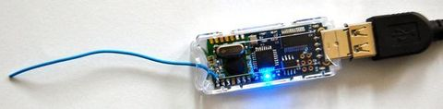

**Figure 3: picture of JeeLink**

**Sensors**

This section gives an overview of the individual sensors that will comprise the sensor node. These nodes include temperature, humidity, ambient light, motion, water flow, water level, power monitoring and soil moisture sensors.

While the JeeLabs Room Board has the four sensors that we desire, we felt that a customized free-wire design offered better flexibility and allowed for these sensors to be mounted away from the JeeNode. Additionally, we opted to use a less expensive temperature/humidity sensor, saving roughly 50% on the total cost of one sensor node.

**Ambient Light Sensor**

Ambient light sensor is a light-sensitive electronic component that can sense the light level of the environment and send out a corresponding output value. A microcontroller can read this output and then control light applications, such as adjust the brightness of a LCD display, dim lights in a room, etc.

The ambient light sensor we intend to use in this project is the AMBI Light Sensor from Modern Device Company. This board carries a Sharp GA1A1S201WP surface-mount ambient light sensor.

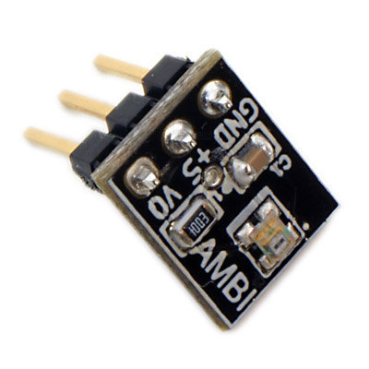

**Figure 4: picture of light sensor**

This light sensor has a spectral response similar to that of the human eye, which means the sensor is highly accurate when used as the basis of an ambient light sensor, and can capture an astonishingly wide range of light values (3 to 55000lux). The sensor works at up to +7V, or down to 3 volts, and operates accurately across a wide temperature range between -40 and +85 C.

**Motion Sensor**

We have chosen the PIR (passive infrared) for motion sensing. This kind of sensor is used for detecting motion by using the IR signal. In this project, we will use this kind of sensor to detect motion when people enter, exit, or move within a room.

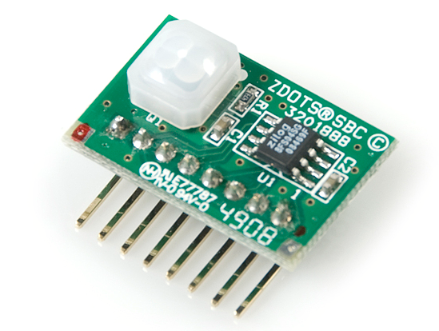

**Figure 5: picture of PIR sensor**

In this project, we will use the Zilog's ePIR which is a fully functional motion-detecting single-board computer (SBC). This ePIR uses a powerful new statistical processing method to provide exceptional motion detection performance.

**Humidity/Temperature sensor**

Humidity and temperature sensors are used for sensing the temperature and humidity of the environment. Based on these values, the sensors will send out corresponding output values. Normally, those sensors are combined into a same unit. In this project, we use the humidity/ temperature sensor DHT22 from Maxdetect Company.

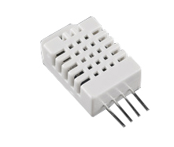

**Figure 6: picture of Humidity/Temperature sensor**

The DHT-22 is a low cost humidity and temperature sensor with a single wire digital interface. The sensor is calibrated and doesn't require extra components so we can get right to measuring relative humidity and temperature.

**Water-Level Sensor**

The ultrasonic sensor is used for measuring distance. An ultrasonic pulse (well above human hearing) is transmitted from the unit to the unit. The distance-to-target is determined by measuring the time required for the echo return.

In this project, we use the PING))) ultrasonic sensor from Parallax.

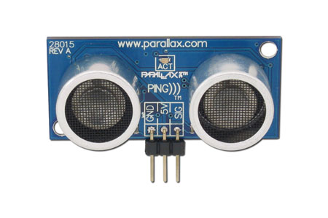

**Figure 7: picture of ultrasonic sensor**

Parallax's PING)))™ ultrasonic sensor provides a very low-cost and easy method of distance measurement. This sensor is perfect for any number of applications that require you to perform measurements between moving or stationary objects. The output from the PING))) sensor is a variable-width pulse that corresponds to the distance to the target.

**Power Monitoring**

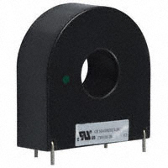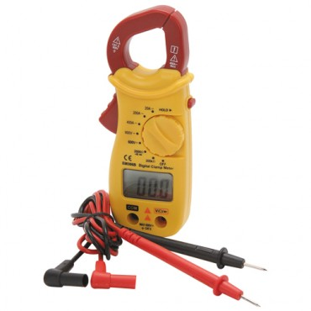

**Figure 8: Clamp and Slide on CT Options**

One method of measuring current flowing in the service conductors near the service panel could be implemented using a clamp on current transformer (CT) available on the Centech digital multimeter. This meter is capable of measuring up to 400 amps. The output of the CT's in this device will be connected to a JeeNode to allow scaling, power calculation and wireless connectivity. In order to measure current in both legs of 120VAC, two of these meters or CT's are necessary. A slightly more invasive approach would be to slide a CT transformer as the one pictured on the right above over service conductors as they enter the service panel. And finally, a less invasive but more expensive approach is the PowerKuff® device. This device (green in image below) simply straps to the outside of the service conduit.

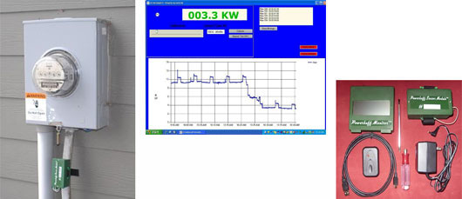

**Water Flow Sensor**

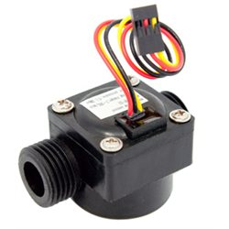

**Figure 9: Seeed Studio Water Flow Sensor**

The water flow sensor will send pulses to a port on the JeeNode at a frequency of 0 to 450Hz, corresponding to a flow from 0 to 15.84 gallons/minute. These pulses will be counted and divided by a time period to produce a gallon per minute calculation. This value is available to the server via the connected JeeNode.

**Soil Moisture**

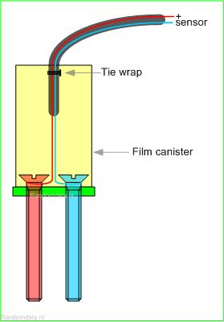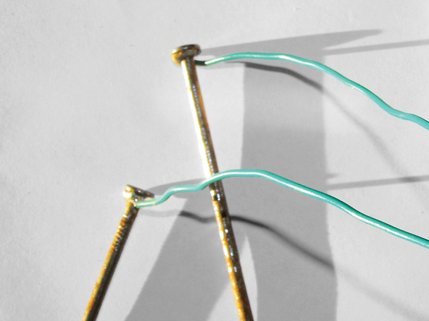

To measure soil moisture, we will build a simple two-stake sensor attached to the analog port on a JeeNode. The JeeNode will provide calculation of soil moisture based on measured resistance and then wirelessly transmit this data to the central server. This sensor can be as simple as two galvanized nails or screws separated by a given distance.

**Overview of Outputs**

**Dimming Lights/Outlet Controls**

Due to concerns about liability and our desire to be compliant with NEC and local codes, we feel an “off the shelf” dimming and power outlet switching system such as X10, Insteon or Z-wave is appropriate. We will use a JeeNode for remotely locating and signaling the AC control system interface. Arduino libraries are available for X10 signaling and the protocols are documented. This approach has the added benefit of allowing a switch to the compatible and commonly believed to be superior, Insteon product.

**Blinds:**

Blinds will be controlled using a Sensor Node (Ambient light and/or Temp sensors) to send data to the central server. The user can then set appropriate min and max points to open and close the blinds automatically via a JeeNode that will be connected to the blind motor.

**Composting toilet motor:**

An appropriate DC motor will be connected to the composting toilet’s exterior crank. The user will be able to control the activation of this motor via an attached JeeNode from the central server.

**Water pump/motor:**

An appropriate pump/motor will be connected to a JeeNode that will communicate with the central server. Again the central server will be programmed with min and max points determined by the user. The data will be obtained from the soil moisture sensor.

**Communication Protocol**

This section explains a possible technique for communication between sensor nodes.

As stated in the system overview, when a node is out of range of the central node, it is necessary to include an “intermediate node” to act as a repeater. This repeater will be responsible for capturing data from the central node and forwarding this data to the remote node and vice versa. To be usable in all cases, we will define a single, comprehensive data frame capable of both node-to-node communication and node-to-remote node repeating/forwarding.

When a node wants to communicate with another node, the data could be packaged in the following manner:

|  |  |  |  |
| --- | --- | --- | --- |
| **Route** | **Action** | **Data** | **End of package** |

**Documentation**

Extensive documentation on theory, assembly, alternatives and modifications will be presented in a intuitive literary and visual form. Links to all online resources will also be included. The open nature of this project invites revisions, refinements and further support from the open-source community.

**Risks and Dependencies**

Besides the advantages mentioned above, there are also some inherent risks with this system.

* Motor for Composting Toilet: Automation is not recommended by manufacturer. Minimum and maximum torque/speed for the composter’s tines is unknown.
* Blind motors: The size, weight and action of the blind is undefined. This increases the complexity of choosing an appropriate motor and it's method of control.
* The number of sensor nodes needed could change from that specified in this document. Once installation and test coverage is done, the exact number of sensor nodes will be clear. An increase cost is possible.
* The ultrasonic sensor may suffer from water splash damage and humidity buildup.
* Water-flow sensor selected has durability concerns. The inlet size of 1/2” may not suffice for measuring a household. An alternative sensor is available for $80-$300.
* Assembly materials and sensor enclosures will be determined later. The cost for both in this document is only an estimate and could increase or decrease depending on the materials selected.

**Predictable Cost**

**Project Components**

|  |  |  |  |  |  |
| --- | --- | --- | --- | --- | --- |
| **Part Name** | **Part Number** | **Manufacturing** | **Vendor** | **Price per Part** | |
| JeeNode Wireless PCB | JeeNode V5 Kit | JeeLabs | [www.moderndevice.com](http://www.moderndevice.com) | $22.50 |
| DHT22 - Humidity/Temp Sensor | SEN-10167 | Aosong Electronics Co.,Ltd | [www.sparkfun.com](http://www.sparkfun.com/) | $8.96 |
| Ambient Light Sensor | AMBI Light Sensor | Sharp | [www.moderndevice.com](http://www.moderndevice.com/) | $4.47 |
| Motion PIR Sensor | SEN-09587 | Zilog | [www.sparkfun.com](http://www.sparkfun.com/) | $10.76 |
| Ultrasonic (Water Level Sensor) | SEN136B5B | Seeed Studio | [www.robotshop.com](http://www.robotshop.com/) | $15.00 |
| Water Flow Sensor | POW110D3B | Seeed Studio | [www.robotshop.com](http://www.robotshop.com/) | $9.50 |
| SuperSocket - Wall Receptacle Module | SR227 | X-10 | [www.x10.com](http://www.x10.com/) | $15.99 |
| Decorator Dimmer Switch | x10_ws12a | X-10 | <http://www.x10.com/products/x10_ws12a.htm> | $19.99 |

**Sensor Node Cost**

|  |  |  |  |  |
| --- | --- | --- | --- | --- |
| **Sensor Node Package** | **Part Number** | **Manufacturing** | **Vendor** | **Price/**  **Part** |
| JeeNode Wireless PCB | JeeNode V5 Kit | JeeLabs | [www.moderndevice.com](http://www.moderndevice.com/) | 22.50 |
| DHT22 - Humidity/Temp Sensor | SEN-10167 | Aosong Electronics Co.,Ltd | [www.sparkfun.com](http://www.sparkfun.com/) | $8.96 |
| Ambient Light Sensor | AMBI Light Sensor | Sharp | [www.moderndevice.com](http://www.moderndevice.com/) | $4.47 |
| Motion PIR Sensor | SEN-09587 | Zilog | [www.sparkfun.com](http://www.sparkfun.com/) | $10.76 |
|  |  |  | **Total Price Per Sensor Node:** | $46.69 | |

**Research and Testing**

|  |  |  |  |
| --- | --- | --- | --- |
| **Research and Development** | **Purpose** | **Total Cost** | |
| Budget | Component purchases for design and testing | $500.00 |

**Estimated Deployment Cost**

|  |  |  |  |
| --- | --- | --- | --- |
| **Deployment Costs** | **Estimated Nodes** | **Total Cost** | |
| Estimated cost of sensor node deployment | 16 | $747.04 |

It must be noted that the predicted cost do not reflect the expense of the motors nor the building interface materials for the motors. At this time, an estimate of $300 to $400 for the composting toilet DC motor. Until the blinds are fully specified by the sponsor, it would be fairly difficult to identify and price a blind motor.

**Conclusion**

With this wireless sensor network, users can access information about temperature, humidity, light, and occupancy in a room, water level in a container, and power usage via an interface to a central server without directly going to the sensors to read information. Users are able to control outputs such as motors and light levels wirelessly. Moreover, this wireless system will meet our goal in terms of power-efficiency and cost effectiveness. The data that is gathered via the sensors nodes will assist the home owner in reducing energy consumption as well as making the home more energy efficient through automation.